**1. Check if your processor supports Intel/AMD virtualization technology. Enable Intel virtualization technology in BIOS if possible.**

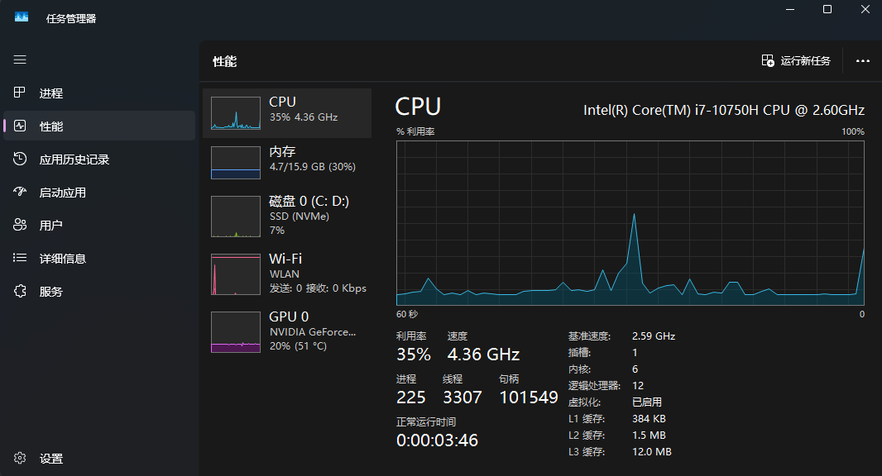

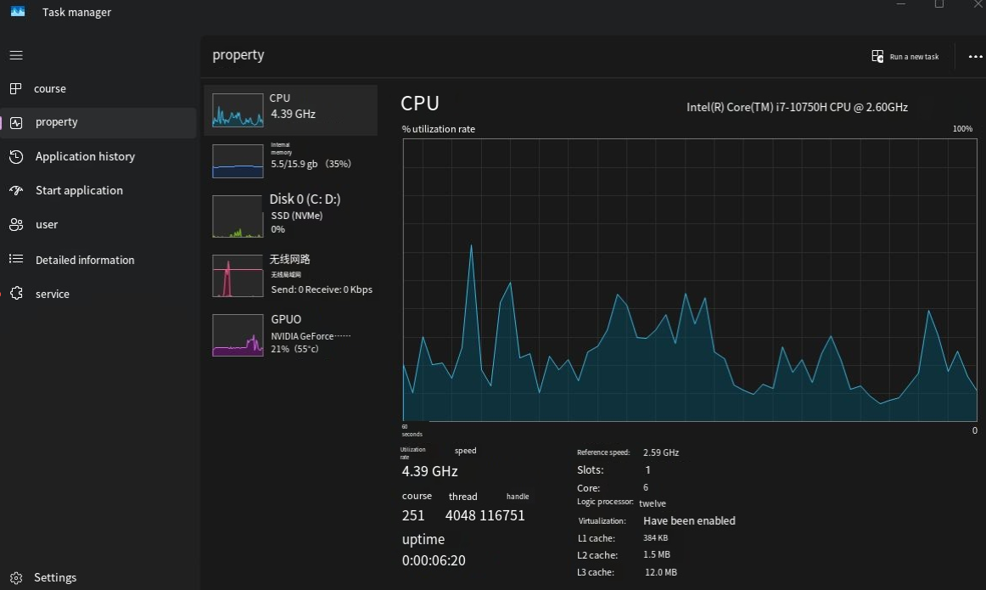

**2. The cloud is almost everywhere in our lives now. What do you think are the fundamental reasons behind its success? Name three pros and three cons of cloud.**

1. Fundamental Reasons for Cloud Success:

* Scalability: The cloud allows businesses and individuals to scale their resources up or down depending on demand.
* Cost Efficiency: Cloud services often offer pay-as-you-go models, reducing the need for upfront infrastructure investments.
* Accessibility and Collaboration: The cloud enables access to data and applications from anywhere, fostering better collaboration.

1. Pros of Cloud:

* Cost Savings: No need for investing in and maintaining physical hardware.
* Scalability: Resources can be scaled up or down quickly based on need.
* Accessibility: You can access your data and applications from anywhere with an internet connection.

1. Cons of Cloud:

* Security Concerns: Storing sensitive data off-site can increase the risk of breaches.
* Dependence on Internet Connection: Cloud services require a stable internet connection; downtime can disrupt access.
* Limited Control: You rely on cloud service providers for maintenance and security.

**3. What is the primary function of a hypervisor in virtualization?**

The primary function of a hypervisor is to manage and allocate physical resources to multiple virtual machines, ensuring that each VM runs independently and has access to the necessary hardware resources.

**4. What is a virtual machine (VM)?**

A virtual machine is a software-based simulation of a physical computer. It runs an operating system and applications like a physical machine but shares resources with the host system.

**5. What are the benefits of using virtual machines?**

* Resource Efficiency: VMs allow multiple operating systems to run on a single physical machine, maximizing hardware utilization.
* Isolation: VMs provide isolation between different environments, preventing issues in one VM from affecting others.
* Flexibility: VMs can be easily cloned, migrated, or backed up.
* Cost Savings: Running multiple VMs on a single physical host can reduce hardware costs.

**6. List five use cases of virtual machines.**

* Software Testing: VMs allow testing of different OS environments or versions without affecting the host system.
* Server Consolidation: Running multiple VMs on a single physical server reduces hardware costs.
* Disaster Recovery: VMs can be backed up and restored more easily than physical machines.
* Development Environments: Developers use VMs to test software across different operating systems without needing multiple physical devices.
* Running Legacy Software: Older software that only runs on outdated OS versions can be virtualized to run on modern hardware.

**7. In virtualization, what is the guest operating system?**

**a) The main operating system running on the physical machine**

**b) The operating system installed on a virtual machine**

**c) The operating system running on a remote server**

**d) The operating system running on a mobile device**

b) The operating system installed on a virtual machine.

**8. What does virtual machine isolation mean?**

**a) Virtual machines can communicate directly with the physical hardware.**

**b) Virtual machines share the same resources and cannot be isolated.**

**c) Virtual machines run independently and are isolated from each other and the host system.**

**d) Virtual machines can only be accessed locally.**

c) Virtual machines run independently and are isolated from each other and the host system.

**9. What is the benefit of virtual machine portability?**

**a) It allows virtual machines to communicate with each other easily.**

**b) It ensures faster boot times for virtual machines.**

**c) It allows virtual machines to be moved between different physical machines with compatible hypervisors.**

**d) It reduces the need for hardware virtualization.**

c) It allows virtual machines to be moved between different physical machines with compatible hypervisors.

**10. What is the purpose of cloning a virtual machine?**

Cloning a virtual machine creates an identical copy of the VM, allowing you to deploy multiple instances of the same setup quickly or preserve a configuration for testing or backup purposes.